STUDIO HBA BRINGS A TASTE OF KOLKATA WITHIN THE TAJ BENGAL’S NEW RESTAURANT CONCEPT, CAL 27;
DESIGNERS INFUSE THE RICH CULTURE OF THE REGION TO CREATE A STYLIZED FINE DINING EXPERIENCE
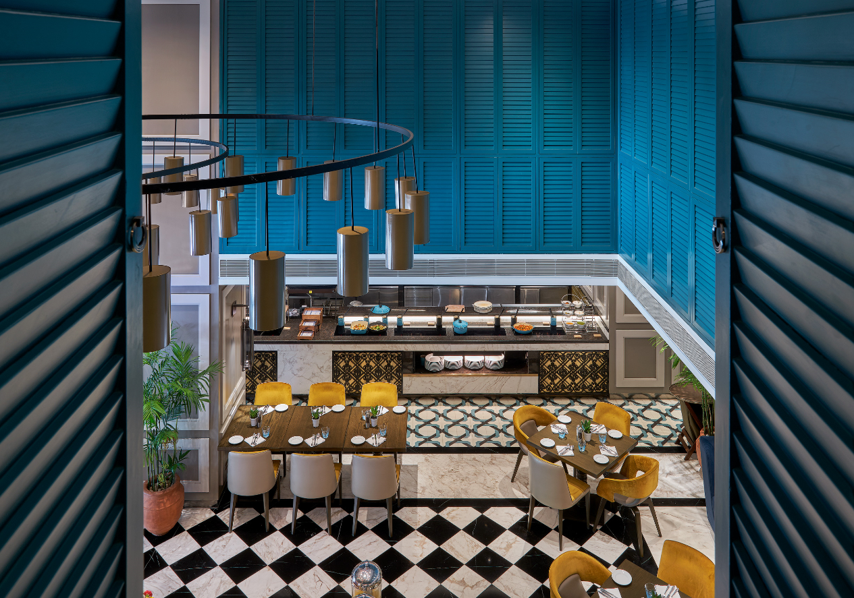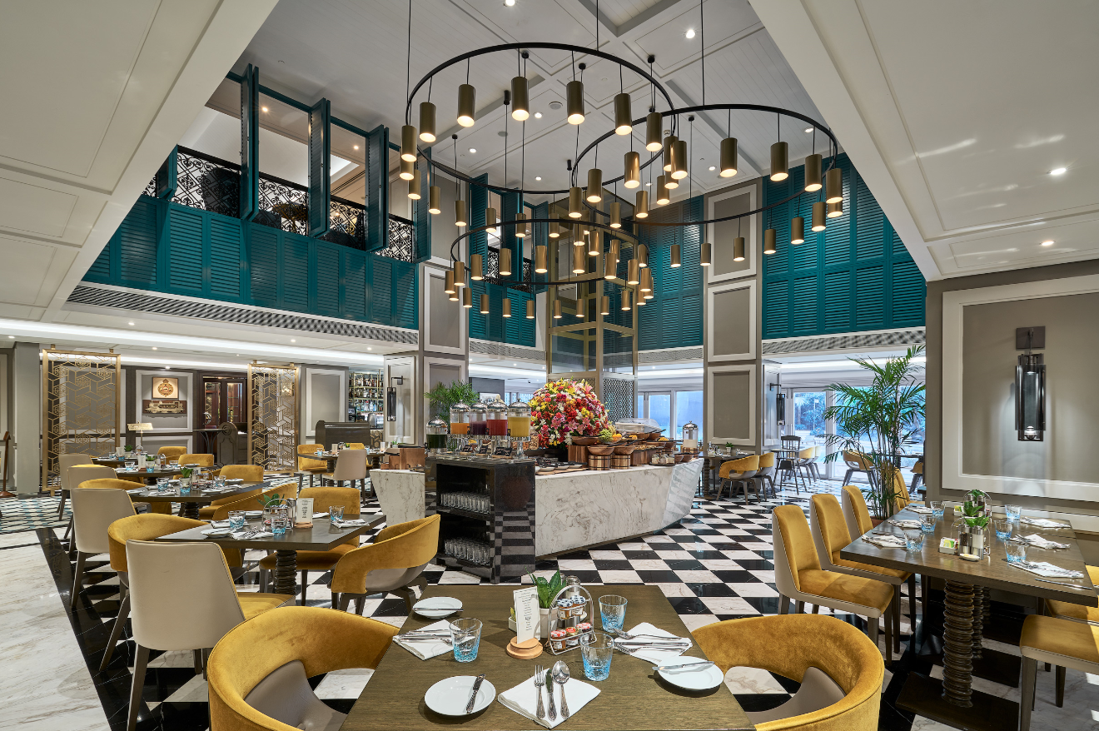
MUMBAI (June 22, 2018) – West Bengal’s famed Taj Bengal Kolkata reveals its highly-stylized new fine dining restaurant, Cal 27, and further elevates the luxury experience for guests and diners. Studio HBA was tapped to orchestrate a space that infuses the distinctive cultural elements of Kolkata throughout the restaurant, carefully weaving inspirations from the city in each space.
“The city of Kolkata is the soul of east India – a vibrant hub of culture, commercial and academics, Kolkata is known as ‘The City of Joy,’” said Studio HBA Partner Rahul Shankhwalker. “Having an opportunity to design within India’s cultural capital was a humbling challenge our team was ready to take on. Coupled with the change to work within the illustrious Taj Bengal hotel made this project one of passion and perseverance. We spent more than a year studying the location, talking to its people and simply absorbing all that this mesmerizing city had to offer in order to create a restaurant space worthy of its location.”
The richness of the city is felt throughout the Cal 27 space – touching The Hub and The Heaven outlets within it to coalesce a storied design. Studio HBA focused on procuring local elements and assembled them in artistic ways to pay homage to the setting. A lively blue and yellow color palette represents Kolkata’s signature taxi cabs while black and white prints display iconic Kolkata elements. The blue and yellow colors appear as velvet and leather covers for the furnishings. Wooden window shutters were inspired by the rolling shutters of Kolkata while table legs took a nod from the four-post beds found in so many of the homes. Old Kolkata Rajbaris served as inspiration for the checkered floors and courtyard concepts and the city’s iconic chai tea cups were translated in to lamp shades.
Taking into consideration the importance of food and festivity the city is known for, the design had to parallel the warmth and inviting nature of the region. “Kolkata thrills outsiders who first arrive and then quickly becomes a part of their soul. It’s transformative in that way and always on the move – we created a space that could serve as a culinary hub and yet remain dynamic and modern.”
Studio HBA left no space untouched, from the ceiling patterns and frames used to depict the wooden rafters and beams reminiscent of the old colonial buildings to the floors laid with timber, stone and terrazzo tiles in intricate patterns that define the space and its local artistry.
In collaboration with Illuminate, HBA’s lighting consultancy, the design team strategized a lighting program that complemented the thoughtful design. Main accent lights were designed to resemble the chai tea glasses that are fundamental to the Bengalis. Vidyasagar Setu, the longest cable stayed bridge in India, gave inspiration for the pulley lamps that hover over seating spaces.
###
About Studio HBA
Studio HBA is a division of Hirsch Bedner Associates (HBA), the world’s leading hospitality design firm, and carries HBA’s DNA in its daily practice. Studio HBA specializes in servicing an international client base with smaller fee budgets and caters to local hoteliers and developers to deliver cutting-edge design solutions. The young, energetic, research-based design practice collaborates closely with clients and stakeholders to complete projects that meet exacting budget demands and brand requirements within limited timeframes. Studio HBA’s project resume includes hotels, resorts, private residences, show flats, restaurants, spas, clubs and corporate offices. The practice crafts a tailored approach to each project, enabling the firm to be a single-source hospitality provider with services including: interior design, architecture, art consultation, lighting design, graphic design, and FF&E procurement, affording clients the opportunity to choose integrated comprehensive services or from an a la cart menu of disciplines. Studio HBA’s notable projects include Trump Tower Show Flat in Mumbai, Conrad Banglaore, Six Senses Spa Club Mumbai and Lohda Worldone Marketing Suites in Mumbai. http://www.studiohba.com/

About Illuminate Lighting Design
Illuminate Lighting Design is an architectural lighting design consultancy with nine global studios in Singapore, Jakarta, New Delhi, Shanghai, Hong Kong, Melbourne, Los Angeles, San Francisco and Dubai. Illuminate works with architects, interior designers, landscape architects and end clients for hospitality, commercial, residential, mixed use, retail and leisure lighting design projects. View Illuminate’s completed projects at www.illuminateld.com.

