STUDIO HBA TRANSFORMS THE OVOLO SOUTHSIDE HOTEL IN HONG KONG
Newly Renovated Hotel Brings Industrial Chic to the Up-and-Coming Wong Chuck Hang Neighborhood
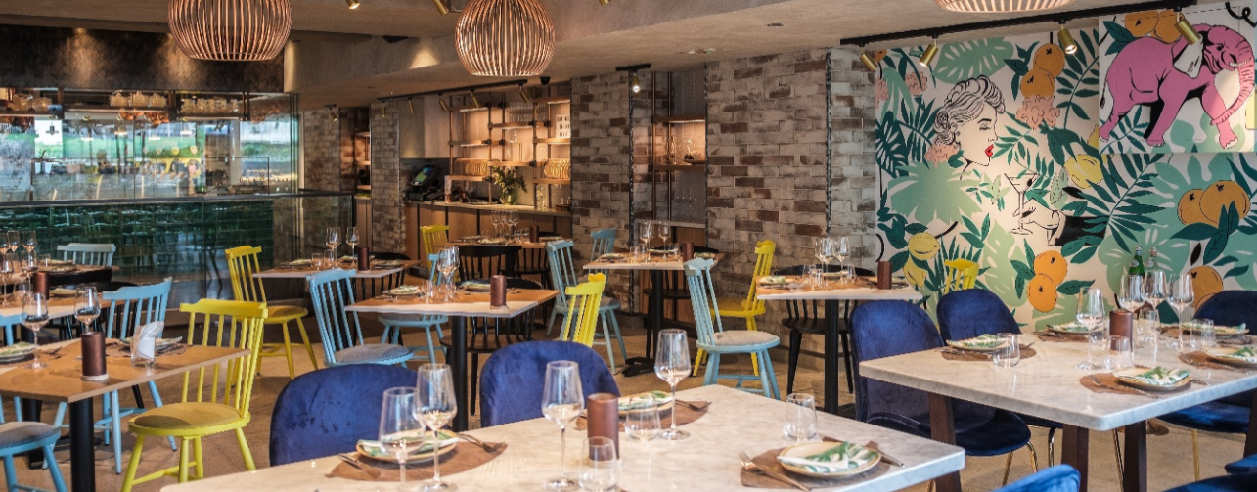
HONG KONG (April X, 2018) - Studio HBA – a division of Hirsch Bedner Associates (HBA), the world’s leading hospitality design firm – has just refreshed the social spaces for modern boutique hotel, Ovolo Southside, in the up-and-coming Wong Chuck Hang neighborhood in Hong Kong. Ovolo Southside is the first warehouse conversion hotel in Hong Kong and pays homage to the thriving shipping industry as well as the design houses and fashion labels that now populate the area.
Studio HBA revived the signature restaurant, CIRQLE; the outdoor rooftop bar, ABOVE; and the lobby. “Everything about these spaces expresses the idea of transformation. This design philosophy was particularly important considering the growing wave of young entrepreneurs who like to work in flexible spaces that cater to many different needs,” said Studio HBA Partner Federico Masin. “ABOVE can be a rooftop bar or reconfigured into a conference room or meeting space fully equipped with a projector and sound system,” he explained.
Upon entering the lobby, guests will be met with witty neon signs and colorful artwork which add an Instagram-worthy pop of color. A fluid layout transition from the warm, playful ambience of a lobby check-in area to an industrial-chic work and play area. The ceiling is exposed and the beams are painted with a splash of white, maximizing the open feel. The container bar, one of two bars in the hotel, is made of corrugated metal and decorated with bright colors, paying homage to the shipping history of the area.
The designers sought to challenge conventional notions of shared spaces by cutting away part of the floor from CIRQLE, their 4th floor restaurant, creating a duplex locale and bringing in light and enticing guests to explore. Tapping local talent, Hong Kong artists were invited to decorate walls. A mural featuring giant leaves, citrus, and a pink elephant set the mood of the restaurant, while Scandinavian timber pendant lights hang gently over dining tables embellished with colorful and artistic tableware.
An edgy rooftop bar, ABOVE features indoor and outdoor seating which delivers a 270-degree view of Hong Kong’s lush Southern District. Private function room by day, rooftop bar by night, the space features flexible Pacman style tables that come together to form a large meeting table – perfect for meetings or private events – and separated into small seating groups for two or four persons when the bar is open. The effect is a hip, retro-vibe rooftop bar guests can get lost in on a languid weekend afternoon.
###
Media Contact
Daniela Parker / Tiffany Hayden
Daniela.Parker@hba.com / Tiffany.Hayden@hba.com
310.289.9087
About Studio HBA
Studio HBA is a division of Hirsch Bedner Associates (HBA), the world’s leading hospitality design firm, and carries HBA’s DNA in its daily practice. Studio HBA specializes in servicing an international client base with smaller fee budgets and caters to local hoteliers and developers to deliver cutting-edge design solutions. The young, energetic, research-based design practice collaborates closely with clients and stakeholders to complete projects that meet exacting budget demands and brand requirements within limited timeframes. Studio HBA’s project resume includes hotels, resorts, private residences, show flats, restaurants, spas, clubs and corporate offices. The practice crafts a tailored approach to each project, enabling the firm to be a single-source hospitality provider with services including: interior design, architecture, art consultation, lighting design, graphic design, FF&E procurement, affording clients the opportunity to choose integrated comprehensive services or from an a la cart menu of disciplines. Studio HBA’s notable completed projects include Courtyard by Marriott / Hampton Inn, Santa Monica; the Hilton Garden Inn, Singapore; the Hilton Garden Inn, Hongqio, Shanghai; and Kodhipparu, Maldives. http://www.studiohba.com/

